Fort Worth / Tarrant County Aggie Moms’ Club 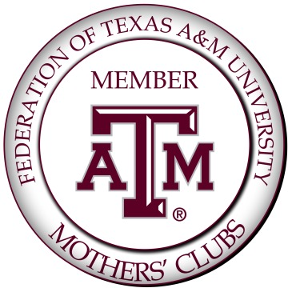

October 16, 2017
Dear Sir or Madam,

I am writing you on behalf of the Fort Worth / Tarrant County Aggie Moms’ Club. We are in our 95th year as an organization, and we are dedicated to providing educational, leadership and personal growth opportunities to students attending Texas A&M University.

In order to do this, however, we rely on our membership and the activities within our membership to generate dues and other sources of income which we convert back into scholarships and grants to student organizations. Last year, we were fortunate enough to be able to provide $10,000 in student scholarships and $4,000 to student organizations.

Each year we hold an annual fundraising event, Silent Auction, along with our famous Chili Cook-Off. We are asking for donations of cash and/or goods which we will use to auction off at this event to Aggies, attending family members, friends and anyone else wanting to help raise funds for our Aggie scholarships. The event will be held on Monday, February 19th at 6:30 p.m. Our meetings take place at the Saint Paul Lutheran Church, 1800 West Freeway, Fort Worth, Texas 76102. Our tax ID number is 75-2009247.

Please send donations to our treasurer: Diana Poulson, 4702 Belle Pointe, Arlington, Texas, 76017. If you cannot mail your donation, please contact committee members: Diana Poulson at 817-343-8102 or ddpoulson@att.net; Torie Deremo at 817-709-4077 or torie.deremo@me.com to arrange for pick up.

Thank you and Gig’em,

Sherry Caver
Auction Chairman

